Ain Shams University

Artificial Intelligence

Fourth Year Second Semester

June 2008

Answer all questions

Question 1:
- For the following term, give the output tree of the unification if it unify or else explain why unification would fail:
Unify ((parents A (father A) (mother aly)), (parents aly (father aly) B))
- Given the following
- if it is sunny and it is warm, then Samy is happy.
- if there is blue sky then it is sunny.
- there is blue sky.
- it is warm.
- is Samy happy?
Use resolution to show Samy is happy

Question 2:
Build a finite state acceptor and transition matrix that recognizes the following:
- All strings of characters from the alphabet {a,b,c,d} that contain the exact sequence “abc”.
- All strings of binary digits{0,1} that contain the exact sequence “111”.

Question 3:
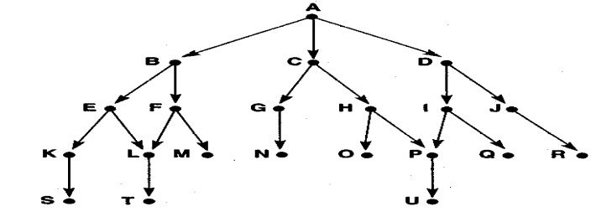
Write and trace the algorithms of Depth-first and Breadth-First search by using this graph.

Good Luck

